# **Password Strength Analyzer with Custom Wordlist Generator.**

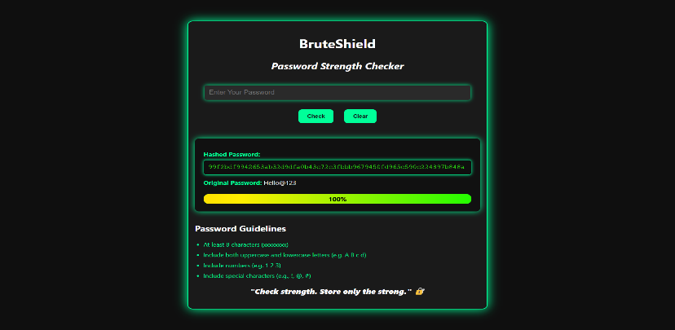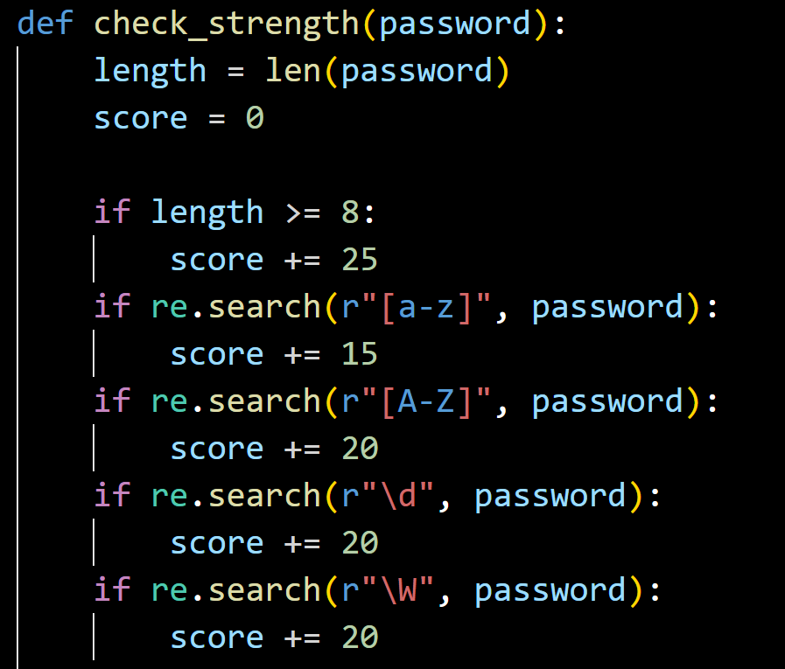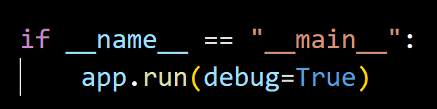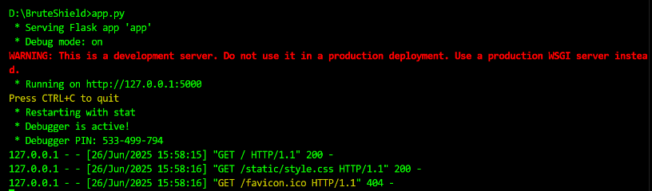

**CONCLUSION:**

The BruteShield – Password Strength Analyzer project successfully demonstrates the importance of creating secure passwords through an intuitive and interactive web application. By integrating Python's Flask framework with a clear UI, users can test the strength of their passwords in real-time based on key security criteria such as length, character variety, and complexity.

The system assigns a dynamic strength score and provides instant feedback with both a numeric indicator and a color-coded progress bar. Additionally, it enhances security awareness by converting passwords into SHA-256 hashes, showcasing how sensitive information can be safely stored or transmitted. The use of cryptographic hashing ensures that the application simulates a real-world approach to password management.

Overall, the project achieves its goal of educating users about strong password practices and demonstrates practical skills in web development, regular expression handling, hashing techniques, and user experience design.

NAME:SK MASOOD ALI

EMAIL: [skmasoodali7@gmail.com](mailto:skmasoodali7@gmail.com)

Contact No:9078441493